5.90: Since the larger block (the trailing block) has the larger coefficient of friction, it will need to be pulled down the plane; i.e., the larger block will not move faster than the smaller block, and the blocks will have the same acceleration. For the smaller block, and similarly for the larger, 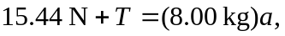 a) Adding these two relations, 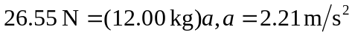 (note that an extra figure was kept in the intermediate calculation to avoid roundoff error). b) Substitution into either of the above relations gives 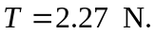 Equivalently, dividing the second relation by 2 and subtracting from the first gives 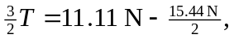 giving the same result. c) The string will be slack. The 4.00-kg block will have 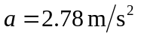 and the 8.00-kg block will have 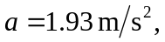 until the 4.00-kg block overtakes the 8.00-kg block and collides with it.

